I. Overview
LESSON TITLE: Me, Myself and I
LESSON SUMMARY: This lesson explores stereotypes that have affected American society. The students will create a triptych of three different self portraits. The first portrait will be a self portrait, the next is a self portrait in a different culture and the last will be a combination of the two. During this lesson we will explore the work of Ivanco Talevski and how he uses the politics and stereotypes with in his pieces.

GRADE LEVEL: high school
ANTICIPATED CLASS SIZE: 30 students
CLASS TIME/DATE: 1 hour 20 minutes 5 days a week 4 sessions

UNIT TITLE: Breaking the Hold: Redefining you in Society
UNIT RATIONALE: Society, whether it be our own or someone else’s, reflects values of a larger body of people. The class shall embark on a journey to explore and rediscover themselves in a society, learn about a history of another society, and state their claims about social issues in society. For the first lesson students shall evaluate their identity in society and how society can affect who they are and who they will become. The second lesson will challenge stereotypes that are created by our society and in other societies and gain a stronger respect for other societies and the people that live in them. Finally, in the third lesson the students will take all of the information they have gathered from the other discoveries and create a propaganda piece based off of a social issue that affects American society.

A. BIG IDEA: Exploring stereotypes in society
B. ENDURING UNDERSTANDINGS: Around the world, stereotypes are often perpetuated in societies. Racial and gender stereotypes are reinforced by the media in American culture through television, movies, music and magazine advertisements. Teenagers and young adults often face a battle between fulfilling certain stereotypes and disproving them. This lesson will explore different stereotypes from around the world as well as the students’ own heritages. The lesson will also reflect on how society views stereotypes.

C. ESSENTIAL QUESTIONS:
- What does stereotype mean?
- How are society and stereotypes related?
- How do stereotypes influence society?

E. MATERIALS/EQUIPMENT, ROOM ARRANGEMENT
1. MATERIALS/EQUIPMENT: 8” x 11” pieces of cardboard, pencils, pens, tempera paint, magazines, rubber cement, markers, pastels, watercolors, construction paper, tissue paper, erasers, exacto knives, rulers.
2. ROOM ARRANGEMENT: There will be six tables with five students at each. The materials will be placed at the front of the room for easy accessibility convenient sharing.

F. VOCABULARY AND REFERENCE/SOURCES
1. VOCABULARY:
A. Ivanco Talevski- An artist that uses influences from his native home Macedonia to create visually stunning etchings, drawings and paintings.
B. Stereotype- a simplified and standardized conception or image invested with special meaning and held in common by members of a group
C. Society- the community of people living in a specific country or region that shares customs, laws, and organizations.
D. Culture- Behaviors and beliefs of certain social or ethnic group.
E. Ethnicity- Traits and background of your culture and society.
F. Balance- harmonious relation of parts to each other or to the whole G. Triptych- a set of three panels or compartments side by side, bearing pictures, carvings, or the like.

2. REFERENCES SOURCES:
- www.ivancotalevski.com

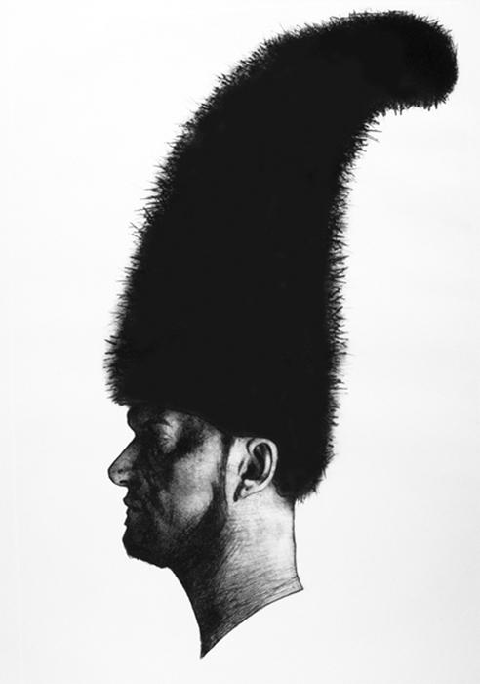Ivanco Talevski- Self Portrait

www.meriamwebster.com

II. STANDARDS/OBJECTIVES
A.STANDARDS
1.1.12.D.1 - Distinguish innovative applications of the elements of art and principles of design in visual artworks from diverse cultural perspectives and identify specific cross-cultural themes.
1.2.12.A.2 - Justify the impact of innovations in the arts on societal norms and habits of mind in various historical eras
1.4.12.A.4 - Evaluate how exposure to various cultures influences individual, emotional, intellectual, and kinesthetic responses to work.
9.1.12.F.5 - Formulate an opinion regarding a current workplace or social/ethical issue based on research.

B. OBJECTIVES

- The students will be able to define stereotypes as ideas, assumptions, or generalizations that people or groups make about characteristics of another person or groups of people.
- The students will be able to relate stereotypes and society through development of ones own culture in order to better understand others by an in class activity of creating a triptych piece of artwork in which they will merge 2 cultural societies into one.
- The students will be able to examine through in class discussions and a lecture on Ivanco Talevski’s artwork how stereotypes can influence your feelings about society and how misunderstandings of someones culture can lead to violence and hatred if simple beliefs and ideas are not communicated to one another well.

III. LEARNING EXPERIENCE

In the introduction of the lesson the classroom will be set up, so that there are six tables, the tables will be covered with balloon of all different colors. Inside the balloon there will be slips of paper that have a specific culture on them. The students will pop the balloons to receive a culture that they will use as part of their triptych. The teacher will ask what the students think about the culture they have received and if they know anything about the culture off hand. After the students sit down there will be a small power point on Ivanco Talevski and how her art embodies stereotypes. When the power point is finished the students will be asked, how did the artist communicate her work, how do stereotypes tie in, and what are the images being shown? The questions will be generally opened ended.

Artist- Ivanco Talevski and artist that develops his own cultural stereotypes form his own cultures through visually stunning etchings, drawings and paintings. The piece of art work that will shown to the class is a self portrait of the artist in a hat from his native country. In his country Macedonia every village has a different hat. In the portrait the artist over exaggerates the hat to make a whimsical statement almost satirical statement about his county.

Art Making activity- The students will make a triptych exploring the big idea of stereotypes that has three different self portraits. The first is a self portrait of themselves, the second is a portrait of the different culture from their popped balloons and the last is a combination of the first two. The students will research these different cultures from the balloons and write a simple page long paper to display their understanding and knowledge of another culture. They will take this research and formulate the second portrait in the triptych of a stereotype about the other culture. Keeping in mind the artist Ivanco Taleski’s artwork and that they are not to be racist or offensive in anyway. After this part is finished they will complete their own stereotypical self portrait part. Tieing in identity in society from lesson 1 the students are to display this. The middle part of the triptych piece will be a joining of the 2 cultures breaking these stereotypes showing a togetherness and advanced display on how stereotypes are misconceptions. A critique will follow at the end having students showing off what they have learned about other societies and how misunderstandings can lead to intolerance and hatred.

