LESSON 3

Colorful Imagination

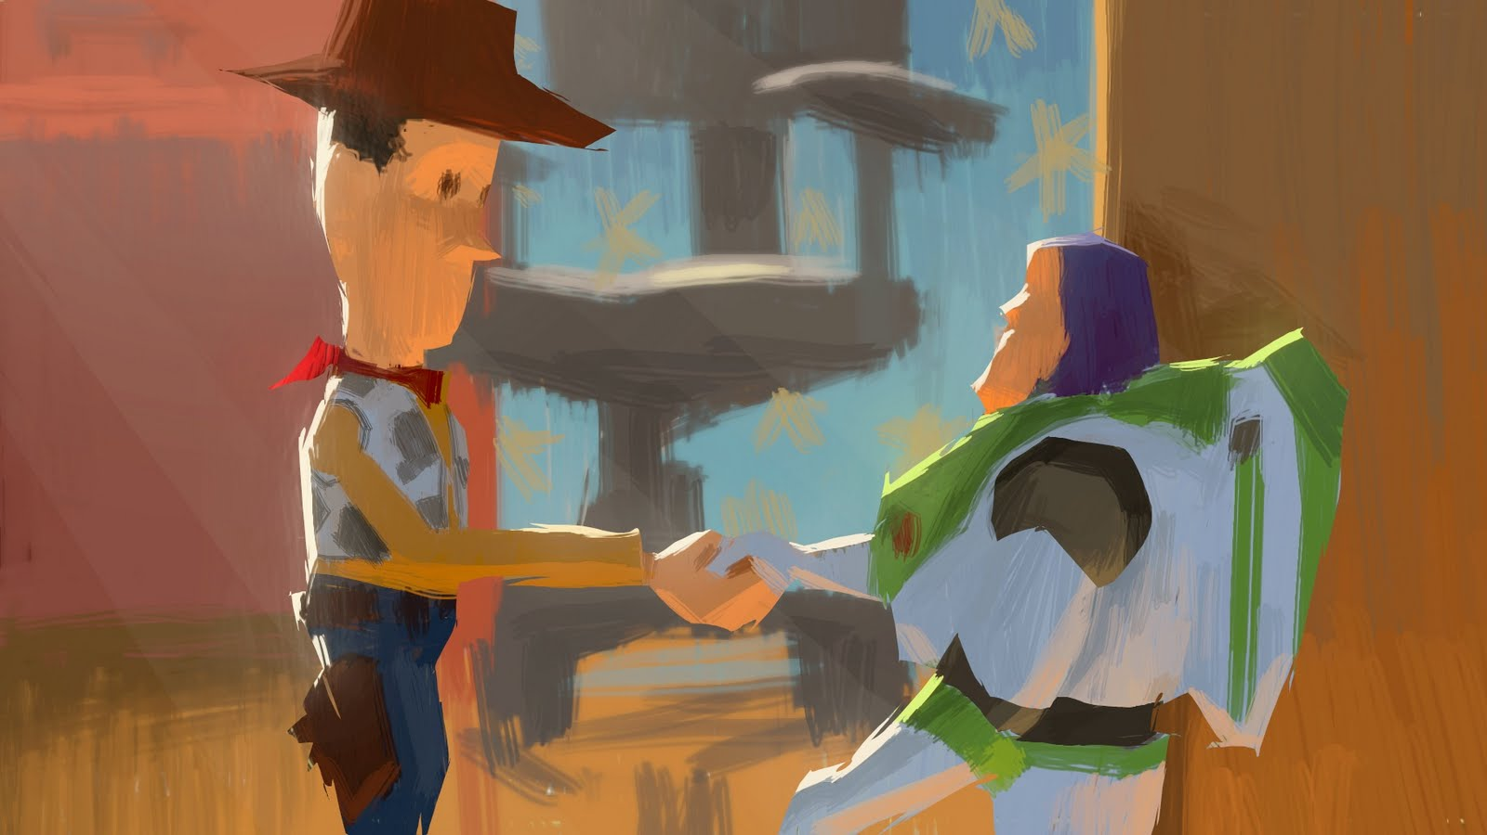

OVERVIEW

BIG IDEA: Storytelling through Color scripts
TEACHER: Timmy Roselle
GRADE LEVEL: 4th grade
CLASS SIZE: 25 students
CLASS TIME: 4 classes, 45 - 50 minutes
UNIT TITLE: Animated Storytelling

UNIT RATIONALE:

Storytelling has shaped our world into the place we know of it today. Without it there would be no such thing as religion, or cultures with traditions, or entertainment as we know it. From the early beginnings it is how we are brought up to shape and mold the world around us. It feeds us our emotions on how we deal with and react to situations within the world and within ourselves.
Elementary students need to know and understand about story telling more than ever. With the introduction of certain technology children at very young ages are disabling their ability to use their imaginations creatively as possible. This unit would benefit younger children in the expansion to come up with ideas never thought before to them and that will further their creativity later in their schooling and life helping them blaze their own path rather than just following one.

KEY CONCEPTS:
- Color Scripts are a visual document or guide showing how colors, and values are displayed in a film.
- Concept art is an illustration where the goal is to express a visual representation of a design, idea, and/or mood for use in a film before it is put into the final product.
- Storytelling is the transmission of events in words, images and sounds by often creativeness and/or exaggeration.
- Color scripts and Concept art are similar but both have vital roles in the development of a story. They are part of the progress where one takes words from the script and brings them into a visual aspect so that others may understand what type of feel and look the film will have with its characters and settings.
- Whether it be a mixture of words, sounds, or visual artist have always used stories to pass on their interpretations of what is going on either around them or in their universe surrounding others.

BACKGROUND INFORMATION:

This being the 3rd lesson students are expected to have a solid foundation of what emotions are, look like and how they help develop a character in a story. Based off the previous lesson they will know what a storyboard is, what makes one up and how they are fully used. Previous discussions and examples will have prepared the students for this lesson and color scripts/concept art. The students will also have the basic skills in the elements of art to complete their in class projects.

MATERIALS/ EQUIPMENT, ROOM ARRANGEMENT:

- Art supply closet/ all of the materials within
- Hand out
- Pens
- Pencils
- Colored Pencils
- Markers
- Paints
- Paint brushes
- 11x17 sheets of white paper
- Canvas board
- Digital Camera
- Computer
- Projector

I will arrange the room by having 5 students at each of the 5 tables. There will be 2 tables on each side and one table in the center.

VOCABULARY/ SOURCES:

- Emotion - Any of the particular feelings that describe such a state of mind, such as joy, anger, love, hate, horror, etc.
- Color Script - A visual document or guide showing how color, and value display in a film.
- Storyboard - A series of drawings posted up on a board, typically with some directions, representing the shots planned for a movie (usually used for animated films).
- Story- An account of an event or a series of events, either true or not.
- Concept Art- an illustration where the goal is to express a visual representation of a design, idea, and/or mood for use in a film before it is put into the final product.
- Storytelling- The transmission of events in words, images and sounds by often creativeness and/or exaggeration.

Resources:
Book: The Art of Pixar.
Websites: http://livlily.blogspot.com/
http://digital-lighting.150m.com/ch12lev1sec1.html
http://www.youtube.com/watch?v=c3pILaQKRKo
http://www.siliconprairienews.com/2010/10/josh-cooley-gives-an-in-depth-look-at-pixar-s-creative-process

STANDARDS:

- 1.1.5.D.1: Identify elements of art and principles of design that are evident in everyday life.
- 1.1.5.D.2: Compare and contrast works of art in various mediums that use the same art elements and principles of design.
- 1.3.5.D.1: Work individually and collaboratively to create two- and three-dimensional works of art that make cohesive visual statements and that employ the elements of art and principles of design.
- 1.3.5.D.4: Differentiate drawing, painting, ceramics, sculpture, printmaking, textiles, and computer imaging by the physical properties of the resulting artworks, and experiment with various art media and art mediums to create original works of art.
- 1.4.5.A.1: Employ basic, discipline-specific arts terminology to categorize works of dance, music, theatre, and visual art according to established classifications.
- 1.4.5.A.3: Demonstrate how art communicates ideas about personal and social values and is inspired by an individual’s imagination and frame of reference (e.g., personal, social, political, historical context).

OBJECTIVES:

- Students will comprehend how an animated story comes together through a video, class discussion and an in class project.
- Students will have built a basic vocabulary associated with the development of a story through discussion and a quiz.
- The students will improve upon selected mediums that they have learned all year exercising proper elements of art.
- The students will comprehend how color scripts and concept art are an important part of story development through discussion and a project.

ESSENTIAL QUESTIONS:
- What is a color script?
- What is concept art?
- What is Storytelling?
- Why do artist use color scripts and concept art to help create stories?
- How do artist use storytelling to inform us about themselves and the culture around them?

INTRODUCTION:

DAY 1: Start with the Do Now guessing game about how many storyboards were made for each move. Hand back their quizzes and go over with the class each answer. The students will be asked if they remember what a color script is and bring them back to speed with everything so far.

DAY 2: Students will get out their sketchbooks and discuss their ideas from the previous class to everyone.
DAY 3: We will go around the room and say aloud what medium they are working in and why as they show off their progress to everyone.

DAY 4: A simple vocabulary quiz will be given to assess the student’s knowledge thus far.

DEVELOPMENT:

DAY 1: A power point presentation will be shown with new definitions (color script, concept art, story telling). A short 8 minute video of Pixar’s Up will be shown to help the students see how the artist use them to get a feel for the film visually. After the video several example slides of more concept art and color scripts will be shown. A class discussion will ensue with questions of why we tell stories and what roles they play in our lives.
The students will then be told of their final project for the unit. I will have written a short story dealing with art supplies coming to life after the students leave for the day. Each student will get a part of a script consisting of a character and the setting (the art room). The students will be expected to use whatever medium they wish and create that character in 2D form. It must be colorful and show the emotions that are being told of in the script. They must also create any part of the art room they wish in their own way using any medium they want. The students will work the rest of the day in their sketchbooks and brainstorm on ideas they might have.

DAY 2: The students will be given all class to work on their projects with assistance from me.

DAY 3: The students will be given all class to work on their projects with assistance from me. They must be finished by the end of this class period.

DAY 4: I will have taken all of the students’ artwork and made a power point presentation out of it, making sure to align it with the story I have written. I will read aloud my story to the students while their artwork is showing on the board during each specific part of the story. The children will watch as their artwork comes alive to form a colorful collaborative class storyboard/movie.

CLUMINATION:

DAY 1: Before the students leave they are to make sure everything is put away and complete an exit pass asking one question they have about the final project.

DAY 2: Before the students leave they are to make sure everything is put away and complete an exit pass telling me why they chose the medium they are working in.

DAY 3: Before the students leave they are to make sure everything is put away and complete an exit pass by writing down why storytelling is important to them.

DAY 4: End the day with a discussion about what we learned for the lesson and complete an exit pass by writing down if they liked or disliked the lesson and why.

ADAPTATIONS:

ADD/ADHD: For students with attention disorders I will limit their options if need be on which materials they should use. While they are working I can play music and have specific assigned seating. It will be in areas that will not be as visually or psychically distracting by other students.

Auditory Impairments: For students with auditory disabilities they will be given all notes, lectures, and directions typed up before the class begins so that they may follow along during the day. They will be sat close to my desk or area so when I am going over the power point or lectures they can have a good line of sight at my face. Extra example slides may be added to improve communication/directions between the student and myself.

Physical Disabilities: For students that have a physical disability such as a wheel chair or hand crutches special seating areas will be designated for them. I will also already have specific supplies within reach for these students along with an assigned buddy to help the student out if I am not there to directly help the student right away.

ASSESSMENT:

- Students’ ability to understand emotions and what they mean.
- Students’ ability to stay on task and complete the assigned project.
- Students’ participation throughout class time.
- Students’ ability to grasp the concept of using emotions to build characters development
- Students’ feedbacks by how excited and into the project they were.
- Students’ ability to understand a color script and its function.
- Students’ ability to understand concept art and its function.
- Students’ ability to understand the importance of storytelling.
- Students’ ability to use their imagination.
- Students’ ability to critique work.
- Students’ ability using the proper elements of art.

